Assignment 1 | 21st January 2021
Javascript Essentials | Jan 2021 B1

Question 1 What will the code below output to the console and why ?
a.) console.log(1 + "2" + "2");
b.) console.log(1 + +"2" + "2");
c.) console.log(1 + -"1" + "2");
d.) console.log(+"1" + "1" + "2");
e.) console.log( "A" - "B" + "2");
f.) console.log( "A" - "B" + 2);

Answer 1.
- ) output:- 122
Because the “2” is considered as a string and hence it gets concatenated so the output is 122.

- ) output:- 32
Because first 2 has a “+” operator hence it gets added to the 1 and the second 2 is considered as a string and is concatenated.

- ) output:- 02
Because 1 has a “-” operator hence it gets subtracted from 1 and the 2 is considered as a string and is concatenated.

- ) output:- 122
Because every string has “+” operator hence all the strings get concatenated.

- ) output:- NaN2
Because “A” and “B” are strings so the output is Not a Number(NaN) so they can’t be subtracted and the 2 is concatenated at end.

- ) output:- NaN2
Because “A” and “B” are strings so the output is Not a Number(NaN) so they can’t be subtracted and the 2 is concatenated at end.

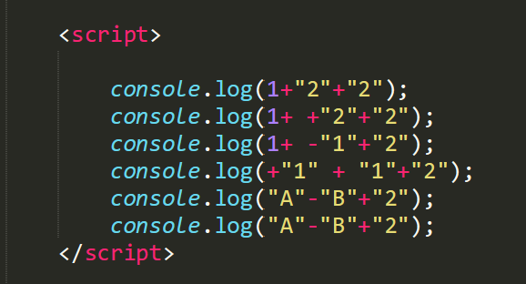
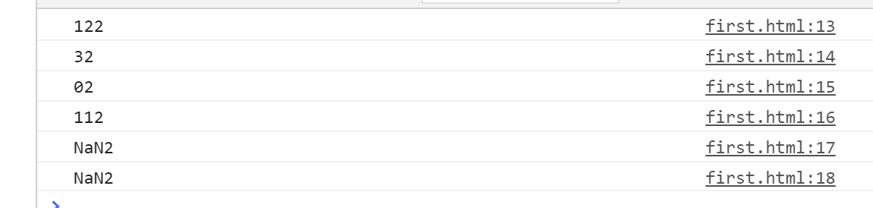

Question 2 You are given a variable “marks”. Your task is to print: - AA if the mark is greater than 90 - AB if the mark is greater than 80 and less than or equal to 90 - BB if the mark is greater than 70and less than or equal to 80 - BC if the mark is greater than 60 and less than or equal to 70 - CC if the mark is greater than 50 and less than or equal to 60 - CD if the mark is greater than 40 and less than or equal to 50 - DD if the mark is greater than 30 and less than or equal to 40 - FF if the mark is less than or equal to 30

Answer 2.
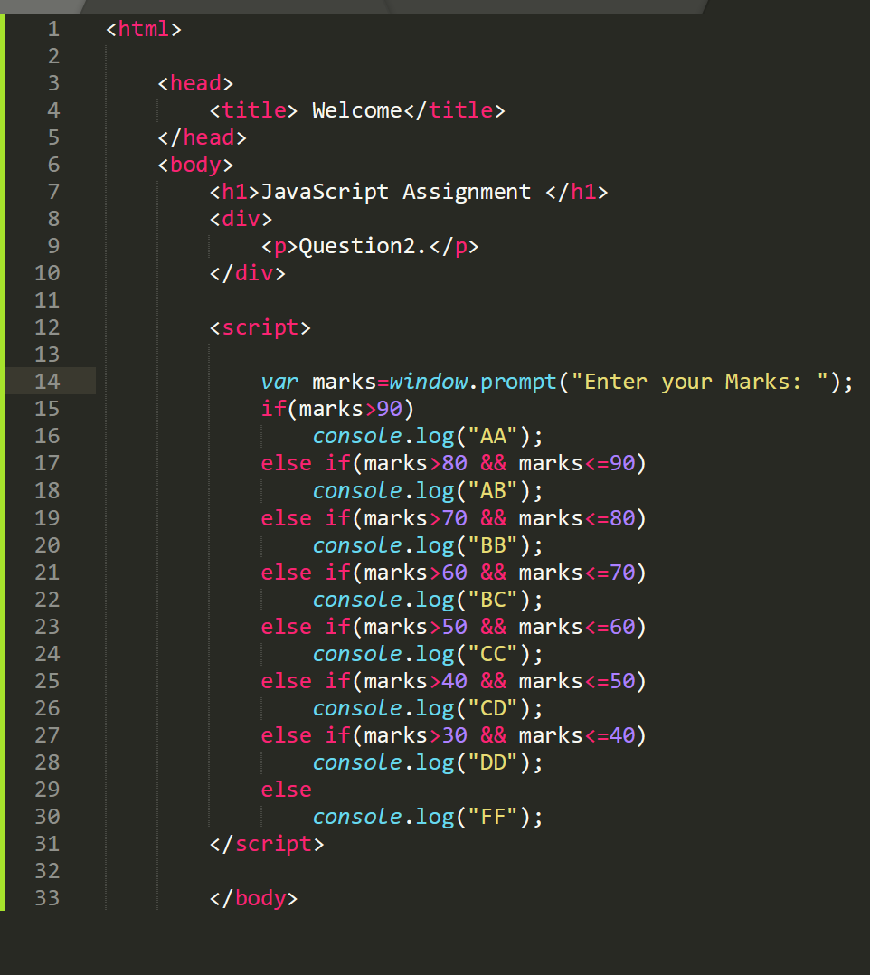

Outputs:-
